UCS406
DATA STRUCTURES AND ALGORITHMS
PROJECT REPORT ON

“DICTIONARY”
USING BINARY SEARCH TREES

SUBMITTED BY:
MADANJEET KUMAR 101603176
MADHAV ARORA 101603177
MAGANJOT SINGH 101603179
MANISH AGGARWAL 101603183
MANRAJ SINGH 101610052
BATCH COE-13



SUBMITED TO:
Dr, Ashish Aggarwal
Lecturer

DEPARTMENT OF COMPUTER SCIENCE AND ENGINEERING, THAPAR INSTITUTE OF ENGINEERING AND TECHNOLOGY

SESSION JANUARY-MAY 2018

TABLE OF CONTENT

S.No. | Title | Page No.
1 | Problem Formulation | 2
2 | Analysis of Problem | 3
3 | Data Structure and Algorithmic Technique Used | 4
4 | Methodology in form of pseudocode/flowchart/algorithm | 7
5 | Results and Conclusion | 25
6 | References | 26

SECTION-1
PROBLEM FORMULATION

  - Introduction To The Game
A dictionary, sometimes known as a wordbook, is a collection of words in one or more specific languages, often arranged alphabetically (or by radical and stroke for ideographic languages), which may include information on definitions, usage, etymologies, pronunciations, translation, etc. or a book of words in one language with their equivalents in another, sometimes known as a lexicon. It is a lexicographical product which shows inter-relationships among the data.

Here, we’ve tried to formulate a basic dictionary that implements basic operations like insertion, deletion, searching, traversal etc. using our understanding of java and data structures including trees, linked lists etc.

  - Rules And Regulations
- The elements are inserted in a Binary Search Tree
- Smaller Elements are inserted to the left of the parent
- Larger Elements are inserted to the right of the parent
- Traversal shall be in order to get a sorted list
- To delete a node, the child nodes of the node to be deleted should be linked to the parent node

  - Problems Encounter During making of the Dictionary
- Insertion of elements as a string
- Scope of the functions
- Insertion of the same word using lower and upper cases was occurring, causing duplication

SECTION-2
ANALYSIS AND ILLUSTRATION OF PROBLEM

  - Analysis of problem w.r.t. Data structure and Algorithmic technique used.

Data Structure used: Binary Search Tree
Algorithm Technique used: In Order Traversal

  - Illustration

SECTION-3
DATA STRUCTURAL ANALYSIS

3.1 Data Structure Used: BINARY SEARCH TREE
Binary Search Tree, is a node-based binary tree data structure which has the following properties:
- The left subtree of a node contains only nodes with keys lesser than the node’s key.
- The right subtree of a node contains only nodes with keys greater than the node’s key.
- The left and right subtree each must also be a binary search tree.
There must be no duplicate nodes.

The above properties of Binary Search Tree provide an ordering among keys so that the operations like search, minimum and maximum can be done fast. If there is no ordering, then we may have to compare every key to search a given key.
Searching a key
To search a given key in Bianry Search Tree, we first compare it with root, if the key is present at root, we return root. If key is greater than root’s key, we recur for right subtree of root node. Otherwise we recur for left subtree.
Hash Table supports following operations in Θ(1) time.
1) Search
2) Insert
3) Delete
The time complexity of above operations in a self-balancing Binary Search Tree (BST) (like Red-Black Tree, AVL Tree, Splay Tree, etc) is O(Logn).
So Hash Table seems to beating BST in all common operations. When should we prefer BST over Hash Tables, what are advantages. Following are some important points in favor of BSTs.
- We can get all keys in sorted order by just doing Inorder Traversal of BST. This is not a natural operation in Hash Tables and requires extra efforts.
- Doing order statistics, finding closest lower and greater elements, doing range queries are easy to do with BSTs. Like sorting, these operations are not a natural operation with Hash Tables.
- BSTs are easy to implement compared to hashing, we can easily implement our own customized BST. To implement Hashing, we generally rely on libraries provided by programming languages.
- With Self-Balancing BSTs, all operations are guaranteed to work in O(Logn) time. But with Hashing, Θ(1) is average time and some particular operations may be costly, especially when table resizing happens.

3.1 Search and Traversal Technique Used: IN ORDER TRAVERSAL
Unlike linear data structures (Array, Linked List, Queues, Stacks, etc) which have only one logical way to traverse them, trees can be traversed in different ways. Following are the generally used ways for traversing trees.
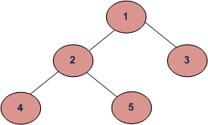
Example Tree
Depth First Traversals:
(a) Inorder (Left, Root, Right) : 4 2 5 1 3
(b) Preorder (Root, Left, Right) : 1 2 4 5 3
(c) Postorder (Left, Right, Root) : 4 5 2 3 1
Breadth First or Level Order Traversal : 1 2 3 4 5
In case of binary search trees (BST), Inorder traversal gives nodes in non-decreasing order. To get nodes of BST in non-increasing order, a variation of Inorder traversal where Inorder itraversal s reversed, can be used.
Example: Inorder traversal for the above given figure is 4 2 5 1 3.
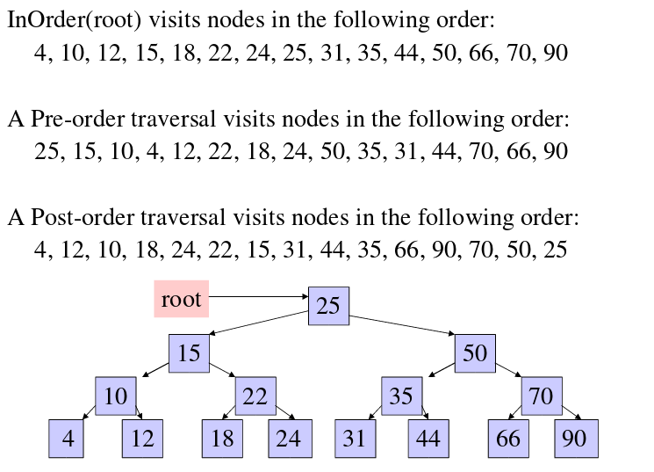

Time Complexity: O(n)
Let us see different corner cases.
Complexity function T(n) — for all problem where tree traversal is involved — can be defined as:
T(n) = T(k) + T(n – k – 1) + c
Where k is the number of nodes on one side of root and n-k-1 on the other side.

SECTION-4
METHODOLOGY

4.1 Algorithm for the Dictionary

import java.util.*;

class node
{
// declaring the left and right children of the node.
node left;
node right;

// declaring the word and the meaning fields for a node object.
String word;
String meaning;

// initializing the fields through a parameterized constructor.
node(String p, String q)
{
this.word =p;
this.meaning =q;

}
}

class finaldictionary
{
// declaring the root of the dictionary as a global variable.
static node root=null;

//function for the insertion of words into the dictionary.
public static void insert(String p,String q)
{
node tr_node=root;// a pointer to keep the track of the current node.
node pr_node=root;
if(pr_node!=null)
{
if((pr_node.word).equals(p))
{
System.out.println();
System.out.println("duplicate element found so there is no need to insert that element");
System.out.println();
return;
}
}

node parent=null;// a pointer to keep the track of the parent of the currently pointed node.

node temp=new node(p,q);// creation of a new node.
// the word and meaning fields are initialized through the constructor.

if(root==null)
{
// if the root is being inserted, that is the first word is being inserted in the dictionary.
root=temp;
return;

}

while(tr_node!=null)// the loop runs until we reach the leaf node.
{

if(p.compareTo(tr_node.word)<0)
{
//if the word to be inserted lies left to the word contained in the current node.
parent=tr_node;
tr_node=tr_node.left;

}

else
{
//if the word to be inserted lies right to the word contained in the current node.
parent=tr_node;
tr_node=tr_node.right;

}

}

if(parent!=null)
{
//the parent is the leaf node now.
if(p.compareTo(parent.word)<0)
{
// the word will be inserted as the left child of the parent.
parent.left=temp;

}

else
{
//the word will be inserted as the right child of the parent.
parent.right=temp;

}
}

}

//function to display the words in the dictionary in the alphabetical order.
public static void inorderTraversal(node m)
{
if(m==null)
{
//base case for recursive call.
return;

}

else
{
//calling the function recursively on the left sub-tree.
inorderTraversal(m.left);

//printing the current root node.
System.out.println("word: "+m.word);
System.out.println();
System.out.println("meaning: "+m.meaning);

//calling the function recursively on the right sub-tree.
inorderTraversal(m.right);

}
}

// function to search a word in the dictionary.
public static void findelement(String p)
{
// a pointer to keep the track of the current node which is initialized to the root.
node tr_node=root;

if(root==null)
{
System.out.println("Dictionary is empty ");

}

else
{
//a loop which runs till we find the word in the dictionary or end up traversing without finding the word.

while(tr_node!=null && ((tr_node.word).compareTo(p)!=0))
{
if((tr_node.word).compareTo(p) > 0)
{
//the word is searched in the left sub-tree.
tr_node=tr_node.left;

}

else
{
//the word is searched in the right sub-tree.
tr_node=tr_node.right;

}
}

if(tr_node==null)
{ // if we end up traversing the whole tree without finding the word.
System.out.println();
System.out.println("Word not found ");

}

else
{
//the word was found which made the loop break.
System.out.println();
System.out.println("Word found");
System.out.println();
System.out.println("The meaning of the word is"+" "+tr_node.meaning);

}
}

}

//function to delete a word from the dictionary.
public static void delete(String s)
{
node current=root;
node parent=root;
boolean left=false;
if(root==null)
{
System.out.println();
System.out.println("Dictionary empty no deletion possible");
return;
}
else
{
while(current!=null && (s.compareTo(current.word)!=0) )
{
parent=current;
if(s.compareTo(current.word)<0)
{ left=true;
current=current.left;
}

else
{ left=false;
current=current.right;
}
}

if(current==null)
{
System.out.println();
System.out.println("word not found in the dictionary");
}
else
{
if(current==root)
{
if(root.left==null && root.right==null)
{
root=null;//case1
}
else if(root.left!=null && root.right==null)
{
root=root.left;//case2
}
else if(root.left==null && root.right!=null)
{
root=root.right;//case3
}
else
{
//case when root has 2 children and root is to be deleted
}
}

else
{
if(current.left==null && current.right==null)
{
if(left==true)
{
parent.left=null;
}
else
{
parent.right=null;
}
}

else if(current.left!=null && current.right==null)
{
if(left==true)
{
parent.left=current.left;
}
else
{
parent.right=current.left;
}
}

else if(current.right!=null && current.left==null)
{
if(left==true)
{
parent.left=current.right;
}
else
{
parent.right=current.right;
}
}
else
{
//when current has 2 children.
node right_sub=current.right;
node traverse=right_sub;
node parent2=right_sub;
while(traverse.left!=null)
{ parent2=traverse;

traverse=traverse.left;
}

if(traverse.right==null && parent2!=traverse)
{ parent2.left=null;
traverse.left=current.left;
traverse.right=current.right;
if(left==true)
{
parent.left=traverse;
}
else
{
parent.right=traverse;
}
current.right=null;
current.left=null;
current=null;
}
else if(traverse.right==null && parent2==traverse)
{
traverse.left=current.left;
if(left==true)
{
parent.left=traverse;
}
else
{
parent.right=traverse;
}
current.left=null;
current.right=null;
current=null;
}

else if(traverse.right!=null && parent2!=traverse)
{
//when successor has a right child.
parent2.left=traverse.right;
traverse.left=current.left;
traverse.right=current.right;
if(left==true)
{
parent.left=traverse;
}
else
{
parent.right=traverse;
}
current.right=null;
current.left=null;
current=null;

}
else
{
traverse.left=current.left;
if(left==true)
{
parent.left=traverse;

}
else
{
parent.right=traverse;
}
current.left=null;
current.right=null;
current=null;
}
}
}
}

}
}
public static void main(String args[]) throws Exception
{
System.out.println("This is a project made by"+" "+"1.Manraj"+":101610052"+" "+"2.Madanjeet"+":101603176"+" "+"3.Maganjot"+":101603179"+" "+"4.Manish"+":101603183"+" "+"5.Madhav"+":101603177");
System.out.println();
System.out.println("All are of batch:COE13");
System.out.println();
System.out.println("welcome to our own hand made dictionary");
System.out.println();
Scanner sc=new Scanner(System.in);
char choice;
boolean run = true;
while(run){
System.out.println();
System.out.println("Hello everyone,i am dictionary and i am here to perform following operation");
System.out.println();
System.out.println("1.Insertion in dictionary");
System.out.println();
System.out.println("2.Deletion in dictionary");
System.out.println();
System.out.println("3.Searching in dictionary");
System.out.println();
System.out.println("4.Traversal in dictionary");
System.out.println();
System.out.println("5.Exit");
System.out.println();
System.out.println("Enter your own choice");
System.out.println();
choice=sc.next().charAt(0);
System.out.println("\n");

switch(choice){
case '1':
System.out.println("word to insert");
String a=sc.nextLine();// extra line introduced.
String pp=sc.nextLine();
String ppp=pp.substring(0,1).toUpperCase();
String word=ppp +pp.substring(1).toLowerCase();
System.out.println("meaning");
String mm=sc.nextLine();
String mmm=mm.substring(0,1).toUpperCase();
String meaning=mmm+mm.substring(1).toLowerCase();
insert(word,meaning);
break;
case '2':
System.out.println("enter the word to delete");
String garbage=sc.nextLine();
String ss=sc.nextLine();
String sss=ss.substring(0,1).toUpperCase();
String s=sss + ss.substring(1).toLowerCase();
System.out.println("Are you sure? Y/N");
char check=sc.next().charAt(0);
if(check=='Y' || check=='y')
{
delete(s);
}
else
{
System.out.println("process Terminated!");
}
break;
case '3':
System.out.println("enter the word to be searched for");
String m=sc.nextLine();//extra line introduced.
String ww=sc.nextLine();
String www=ww.substring(0,1).toUpperCase();
String search_word=www + ww.substring(1).toLowerCase();
if(root==null)
{
System.out.println("There is no word in the dictionary yet.Therefore you cann't find the given string in dictionary");
}
else
{
findelement(search_word);
}
break;
case '4':
if(root!=null)
{
inorderTraversal(root);
}
else
{
System.out.println("Dictionary is empty.You cann't use inorder traversal");
}

break;
case '5':
System.exit(0);

default:
System.out.println("you have entered wrong option .Please entered right option\n");
break;
}
}
}
}

4.2 Flowchart for the project

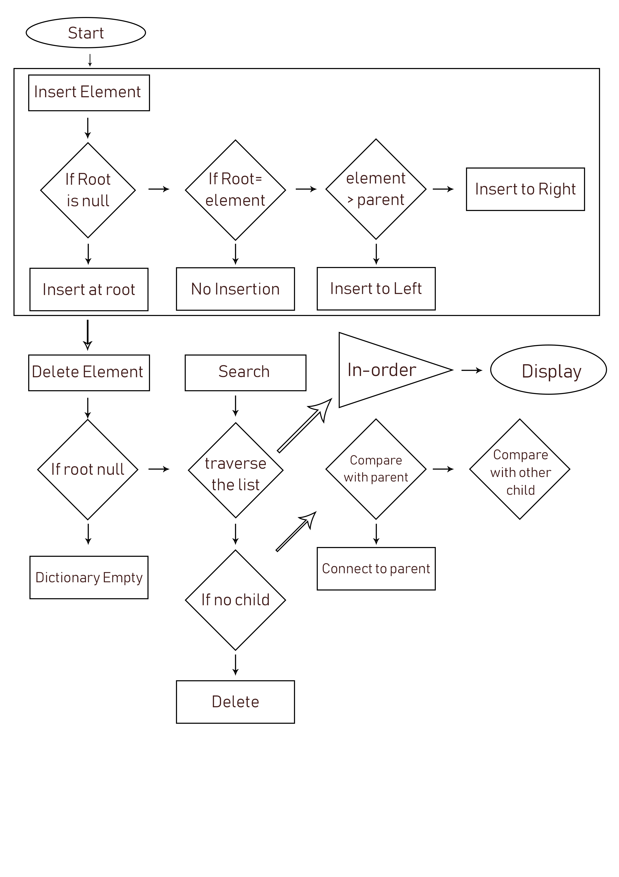

SECTION-5
TIME AND SPACE COMPLEXITIES

5.1 TIME COMPLEXITY

In computer science, the time complexity is the computational complexity that measures or estimates the time taken for running an algorithm. Time complexity is commonly estimated by counting the number of elementary operations performed by the algorithm, supposing that an elementary operation takes a fixed amount of time to perform. Thus, the amount of time taken and the number of elementary operations performed by the algorithm differ by at most a constant factor.

Time Complexity of Dicionary: BIG θ(Log n)

5.2 SPACE COMPLEXITY

Space complexity is a measure of the amount of working storage an algorithm needs. That means how much memory, in the worst case, is needed at any point in the algorithm. As with time complexity, we're mostly concerned with how the space needs grow, in big-Oh terms, as the size N of the input problem grows.

Space Complexity of Dicionary: BIG θ(n)

SECTION-6
RESULT

We have successfully implemented the dictionary by implementing the Binary Search Tree data structure. In this dictionary we have seen that when we search an element, it calls the in-order traversal and whenever we delete a node, the child nodes are analysed and linked to it’s sibling or parent nodes accordingly. Thus, we have developed a fully running basic dictionary on the basis of the concepts and our learning of data structures.

SECTION-7
REFERENCES

1. Geeksforgeeks.org
2. https://www.tutorialspoint.com/java/java_dictionary_class.htm
3. https://stackoverflow.com/questions/13543457/how-do-you-create-a-dictionary-in-java
4. http://see-programming.blogspot.in/2013/05/implement-dictionary-using-binary.html
5. https://www.eecs.yorku.ca/course_archive/2010-11/W/2011/Notes/s11_bin_search_trees.pdf

